**WIND ENERGY PREDICTION USING IBM AUTOAI**

Submitted By:

Satya Mishra

RSIP Career Basic ML 227

**Index**

**1. INTRODUCTION**

1.1 Overview

1.2 Purpose

**2. THEORITICAL ANALYSIS**

2.1 Block diagram

2.2 Software designing

**3. EXPERIMENTAL INVESTIGATIONS**

**4. FLOWCHART**

**5.DATASETS**

**6. RESULT**

**7. CONCLUSION**

**8. ADVANTAGE**

**9.FUTURE WORK**

**10.BIBILOGRAPHY**

**Introduction**

**1.1 overview**

Wind energy plays an increasing role in the supply of energy world-wide the energy output of a wind farm is highly dependent on the weather conditions present at its site. If the output can be predicted more accurately, energy suppliers can coordinate the collaborative production of different energy sources more efficiently to avoid costly overproduction. In this paper, we predict energy prediction based on weather data and analyse the important parameters as well as their correlation on the energy output.

**1.2 Purpose**

Predicting the Energy Output of Wind Turbine Based On Weather Conditions.

**2. THEORITICAL ANALYSIS**

2.1 Block diagram

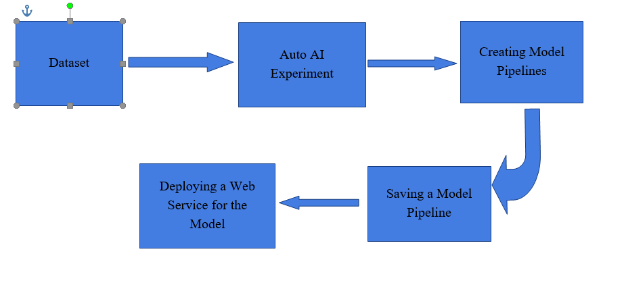

**2.2 Software Desigining**

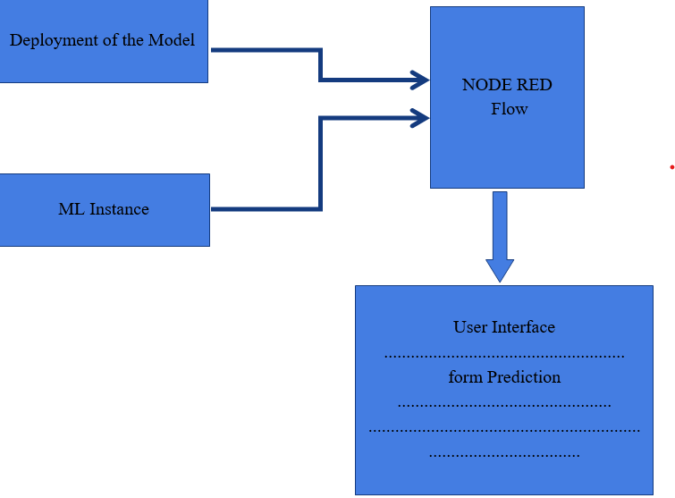

**3. EXPERIMENTAL INVESTIGATIONS** These Dataset consists of prediction of LV active power. These data gives an idea of the analysis of wind power production by different data. Requirements of this model depending upon its power theoretical curve, wind direction and wind speed.

**4. FLOW CHART**

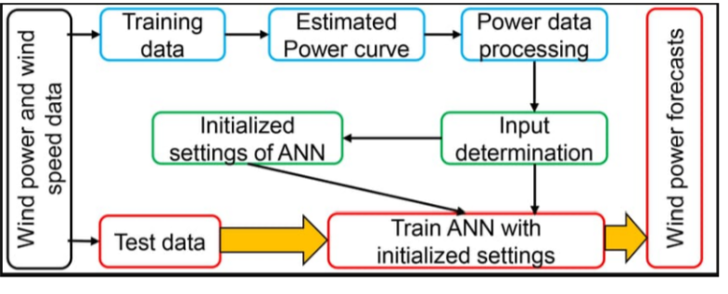

**5. DATASETS**

The data's in the file are:

● Date/Time (for 10 minutes intervals)

● LV ActivePower (kW): The power generated by the turbine for that moment

● Wind Speed (m/s): The wind speed at the hub height of the turbine (the wind speed that turbine use for electricity generation)

● TheoreticalPowerCurve (KWh): The theoretical power values that the turbine generates with that wind speed which is given by the turbine manufacturr.

● Wind Direction (°): The wind direction at the hub height of the turbine (wind turbines turn to this direction automaticaly).

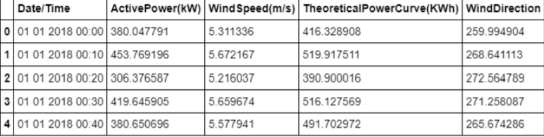

**6.RESULTS**

The model formed using auto AI services in IBM Watson studio can be used to predict live active power of turbine. It is based on theoretical power curve. The Node RED app gives a User-Friendly interface to input the input the value and get prediction.

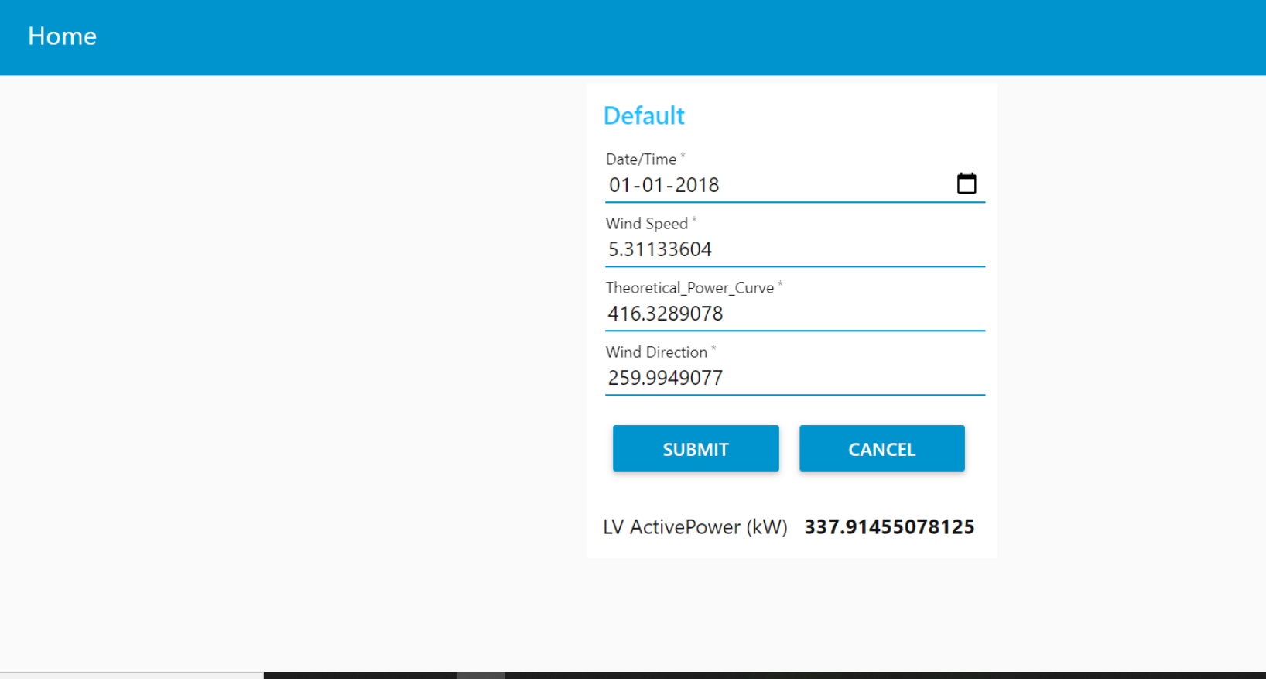

**7.CONCLUSION**

The model is deployed successfully and was used to build a web UI using Node RED services. The model gave satisfactory results and the Web UI is working properly.

**8.ADVANTAGE** Wind energy is available without any cost and it does not emit any greenhouse gases. This makes it a great source of energy production for any developing state. The field of wind energy has tremendous scope for innovation, translating to real world applications and tremendous economic opportunity.

**9. FUTURE WORK**

A wind power forecast corresponds to an estimate of the expected production of one or more [wind turbines](https://en.wikipedia.org/wiki/Wind_turbine) (referred to as a [wind farm](https://en.wikipedia.org/wiki/Wind_farm)) in the near future. By production is often meant available [power](https://en.wikipedia.org/wiki/Wind_power) for wind farm considered (with units kW or MW depending on the wind farm nominal capacity). Forecasts can also be expressed in terms of energy, by integrating power production over each time interval. The grouping of several wind turbines on the same site reduces the investment costs. However, it is important to make an optimal configuration of the turbines locations. For this wind farm site, there will be certain directions for which other turbines affect the production of single wind turbine. A more detailed analysis of this dependence will be made in further work.

**10.Bibilography**

Source of dataset:

<https://www.kaggle.com/berkerisen/wind-turbine-scada-dataset>

Github Repository:

<https://github.com/satyamishra26/Predicting-the-Energy-Output-of-Wind-Turbine-Based-on-Weather-Conditions>